Contact Phone E-mail Date

**Press release**

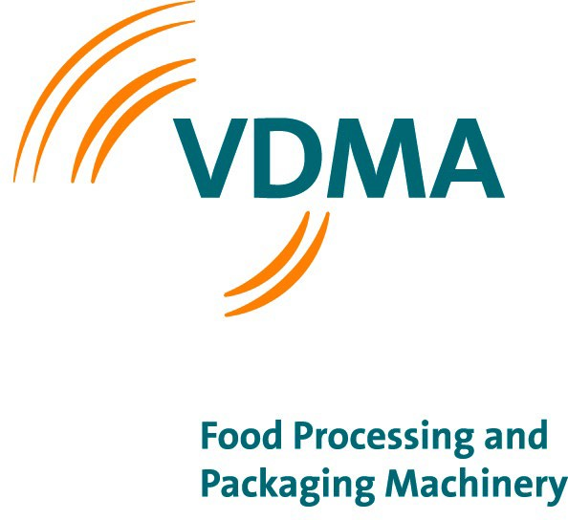Beatrix Fraese

+49 69 66 03-1418

[beatrix.fraese@vdma.org](mailto:beatrix.fraese@vdma.org) 21.04.2022

**drinktec 2022**

Asia: Rising beverage consumption drives investments

*The market potential for the supplier industry in the Asian markets is very positive. This is how the German Engineering Federation (VDMA) assessed the prospects at the online press conference for drinktec 2022 on 7 April 2022. Consumption of beverages is growing at an above-average rate.*

*The VDMA represents the largest group of exhibitors at drinktec and is a supporting partner of the organizer Messe München in market-relevant matters.*

**Frankfurt am Main, 21 April 2022** – According to the VDMA Food Processing and Packaging Machinery Association, the global sales volume of soft drinks will increase by 19 percent to 848 billion liters by 2026. The mechanical engineering association refers to data from the British market research institute Euromonitor International. VDMA further reports that in respect to alcoholic beverages, the market researchers at Euromonitor International expect the global volume sales to also grow by 10 percent to almost 270 billion liters in 2025*.

Asia accounts for almost one-third of total soft drink consumption. The region is also expected to see the strongest growth rate in the period 2021 to 2026. According to Euromonitor International, soft drink sales will increase by 27 percent to 259 billion liters during this period. Bottled water accounts for more than half of these sales, followed by carbonated beverages and tea-based beverages. The highest growth momentum is expected for water (up 37 percent) and energy drinks (up 34 percent) and carbonated beverages (up 24 percent).

Within the Asia region, China is the most important single market for soft drinks, accounting for 45 percent of total sales. It is followed by India, Japan, Indonesia, Thailand, Philippines, Republic of Korea.

**VDMA e.V.**

Lyoner Str. 18

60528 Frankfurt am Main, Germany Phone +49 69 6603-1432

E-Mail [nuv@vdma.org](mailto:nuv@vdma.org) Internet nuv.vdma.org

Reg. of Assn. Local Court Frankfurt/Main, No VR4278

**Food Processing and**

**Packaging Machinery Association**

Chairman: Christian Traumann Managing Director: Richard Clemens

In most countries, soft drink consumption will increase at double-digit growth rates of between 20 and 30 percent until 2026. Highest growth is expected for India with an increase of 83 percent.

Sales of alcoholic beverages in the Asia Pacific region will increase by a total of 4 percent to around 85 billion liters by 2025, according to Euromonitor International. Beer accounts for around 80 percent of alcohol consumption. Sales of spirits are the second most important category with around 11 billion liters. Wine plays the third- largest role with around 5 billion liters. China is also by far the largest market for alcoholic beverage consumption - accounting for 62 percent of alcoholic beverage sales. It is followed by Japan, India, Vietnam and the Republic of Korea.

According to VDMA estimates, the rising consumption of soft drinks and alcoholic beverages will result in further investments in machinery and equipment to establish and expand production capacities.

In the period from 2019 to 2021, machinery and equipment for food processing and packaging worth more than US$6 billion was shipped to Asia from Germany alone. China, the Republic of Korea, Japan and India were the strongest markets for German machinery companies in 2021 and also in previous years.

Total Asian imports of food processing and packaging machinery and equipment have been between US$11 billion and US$12 billion per year in recent years.

Germany, Italy and China are the most important supplier countries for most countries in the Asia region.

* Data for sales of alcoholic beverages are currently only available up to and including 2025.

Do you have any questions? Beatrix Fraese, will be happy to answer them: 069 6603 1418, [beatrix.fraese@vdma.org.](mailto:beatrix.fraese@vdma.org)

The VDMA represents more than 3,400 German and European companies of the mechanical engineering industry. The industry stands for innovation, export orientation and medium-sized businesses. The companies employ around four million people in Europe, more than one million of them in Germany. Mechanical and plant engineering represents a European turnover volume of around 800 billion euros. With a net value added of around 270 billion euros, it contributes the highest share of the entire manufacturing sector to the European gross domestic product.

- 2 -